[insert name here] WOMEN’S SHELTER
ANTI-OPPRESSIVE PROMISING PRACTICE

An Anti-Oppressive Practice/framework (AOP) refers to the processes and methods through which we understand how systems of oppression (colonialism, racism, sexism, homophobia, transphobia, etc.) can result in individual discriminatory actions and structural/systemic inequities for marginalized groups in society (The Office of Equity, Diversity, Inclusion, and Anti-racism, 2023).

Anti-oppressive practices and goals seek to -
- recognize and dismantle such discriminatory actions and power imbalances, that is, systems of oppression.
- disrupt ideologies and assumptions, discriminatory behaviours and structural barriers.
- promotes deep reflection and development of a ‘critical consciousness’ to analyze the ways the service being offered can be complicit in recreating and reinforcing structures of oppression.
  - Critical Consciousness is “The process of continuously reflecting upon and examining how our own biases, assumptions and cultural worldview affect the way we perceive difference and power dynamics” (Sakamoto & Pitner, 2005, p. 441).

Systems of oppression intentionally disadvantage groups of people based on one's identity while advancing members of the dominant group (gender, race, class, sexual orientation, language, etc.).

To begin, consider the following –
- How does my social location create positions of privilege?
- How may social divisions impact my ability to best meet this service user’s needs?
- What’s working from what’s not working? Who is seen vs. who is unseen?
- Who is accessing our support and who is not? Why or Why not?
- What is preventing them from accessing the supports they need? Whose voice is silenced?
- How can I work collaboratively with students or with student organizations/clubs to intentionally offer support that meet a person’s diversely unique needs?

Then consider the following - Principles that may guide an integrated anti-oppressive model:
- Society operates within a socially constructed hierarchy of difference where some people are valued and privileged and others are marginalized and exploited. For example, people living with a disability are devalued by society and their contribution to society is not recognized, solely because of their disability.
- People do not belong to just one category or social location. Our identities are complex and multiple, fluid rather than fixed. As a result, we can be both victims and perpetrators of oppression. We often re-create the relations of social power and control that oppresses us. For example, one may experience oppression because of their female gender but at the same time experience white skin privilege.
- Designating ideas, thoughts and beliefs of people who “belong” towards groups that are highest on the social hierarchy create “dominant culture”. Dominant culture becomes the standard or norm by which everyone is compared. For example, in Canada the dominant cultural norm of women’s clothing does not include wearing the hijab, as a result wearing the hijab is considered unusual and abnormal.
- People who are members of privileged groups have the power to control access to resources and information. This perpetuates the cycle of power and oppression for people who are not members of these groups. People who are marginalized and exploited experience limited access to power that will shape their past, present and future. For example, Canadian history has been written from a colonial, euro-centric lens. This historical perspective is perpetuated through dominant education institutions as the one true version of history.
- Not everyone from the same social group has the same experiences because people have many different lived experiences. When people have multiple marginalized identities, they do not merely face extra barriers; their lived experience is entirely different.
- Integrated anti-oppression work requires that individuals accept responsibility for their role in perpetuating oppression both interpersonally and systemically. To bring about change, individuals and systems must be changed.
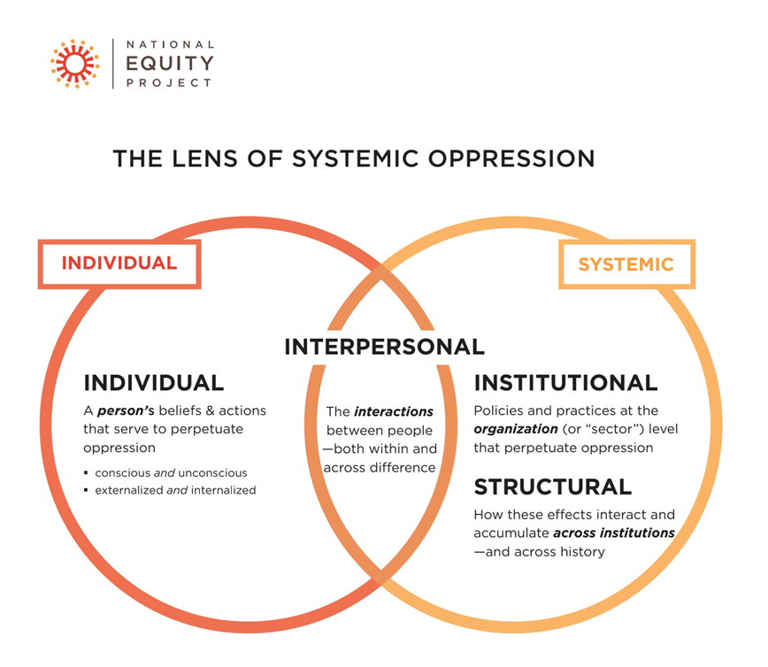

Barriers and challenges to an integrated anti-oppressive approach:
- Not understanding what ‘integrated anti-oppressive work’ means and how to put it into practice
- Feeling overwhelmed by how broad the work is
- Being afraid of change or of losing position, status, privilege
- Being afraid of not being able to accommodate everyone, or of making a mistake
- Not having the will
- Not having the formal power to make changes
- Not being supported by others, or doing the work alone
- Everyone involved is at a different level of understanding

Key components of an anti-oppressive framework that are necessary to implement in order to set strategies and goals for effective outcomes:
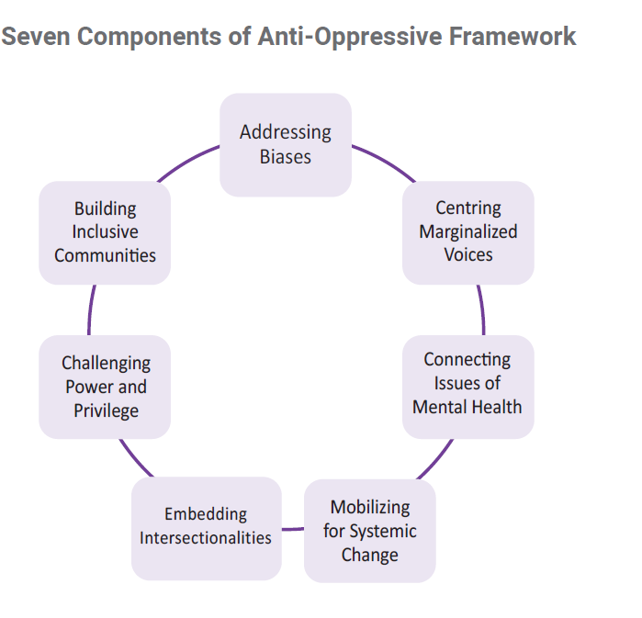
In conclusion, the purpose of anti-oppressive work is to look at systems, not just the individual:
- Research demonstrates that when professional development and actions are directed at addressing structural/systemic changes, its impact is greater and more deeply felt.
- To do integrated anti-oppressive work, organizations should first understand all the ways in which individuals hold power and how they use their power.
  - Begin by asking yourself, “In our organization, which people make the decisions that affect other people’s access to resources?”
  - A hierarchical organization cannot function within an anti-oppressive framework unless its leaders show that they are committed to this approach.
- This approach encourages us not to make assumptions about group identity. It emphasizes that people who share a group identity may or may not have similar characteristics and lived experiences.
  - An integrated anti-oppressive approach reminds us to unlearn what we thought we knew and to think of and work with people as individuals.
- Remember that policies, whether societal or institutional, are created from social norms; they can reinforce hierarchies and can keep people from being involved.
  - Policies that have integrated anti-oppressive practices can create inclusion, connection and shared vision.

https://uwaterloo.ca/equity-diversity-inclusion-anti-racism/sites/default/files/uploads/documents/how-to-build-an-anti-oppressive-practice.pdf
ibid
Springtide Resources Inc, 2008
https://uwaterloo.ca/equity-diversity-inclusion-anti-racism/resources/developing-anti-oppressive-practice-student-services

